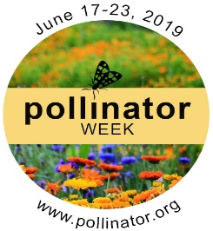
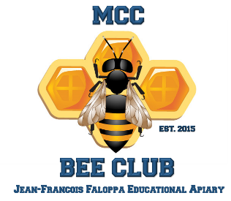
MCC Pollinator’s Day
Celebration
Foods produced with the help of honeybees include apples, strawberries, blueberries, chocolate, melons, peaches, figs, tomatoes, pumpkins & almonds.
About 75% of all flowering plant species need the help of animals to move their heavy pollen grains from plant to plant for fertilization
Why are honeybees so interesting??

Saturday, June 22, 2019 -- 10AM-2 PM
*KID FRIENDLY *
WHAT TO EXPECT: Look inside a beehive behind a glass frame (no risk of stings), suit up and go into a beehive to see how their ecosystem functions, enjoy fresh honey products such as cookies, lemonade, raw honey, and other honey inspired foods, get to know local beekeepers, and how you can help save the honeybees.

ADMISSION: FREE
WHO: People of all ages are welcome
LOCATION: Macomb Community College Apiary
PARKING: please Park in lot 6A

POLLINATOR’S WEEK: June 17-23, 2019
Thank You to Our Sponsors:
McCaulley Heating & Cooling – Queen Bee Level

